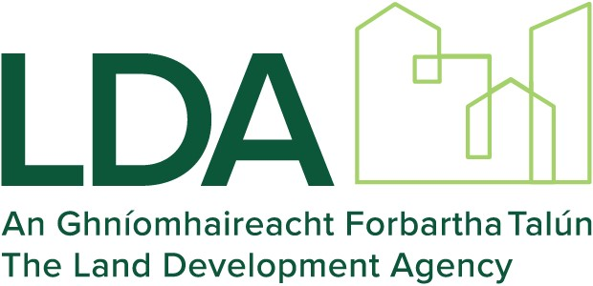

Protected Disclosure (Whistleblowing) Policy

Operations (Compliance/Legal)

Please Note: Only print this document if absolutely necessary. Printing this document may make it obsolete as updates will be published on Bamboo HR in the Governance Framework folder. For the latest version of this procedure always check on Bamboo HR.

Disclaimer – This policy contains information based on Irish law. Please note however that is does not constitute legal advice nor is it intended to provide a comprehensive or detailed statement of the law. This policy is intended as a general guide to the legislation regarding Protected Disclosures and is not a substitute for professional legal advice. All information provided herein is provided without any warranty, express or implied, including as to the legal effect and completeness of the information. No liability whatsoever is accepted by the Land Development Agency for any action taken in reliance on the information contained within this Policy.
Document review and approval
Revision history
Version | Author | Date | Revision
1 | Compliance | 13 October 2020 | Initial version
2 | Senior Legal Counsel | 26 September 2023 | Revisions to take account of the commencement of the Protected Disclosures (Amendment) Act 2022; and input from the Audit & Risk Committee.
This document has been reviewed by
Version | Reviewer | Date reviewed
 | Head of Corporate Services | 14 October 2020
2 | Executive Management Team | 2 October 2023
 | Audit & Risk Committee | 17 October 2023
This document has been approved by
Version | Name |  | Date Approved
 | Board |  | 11 May 2021
 | Board |  | 30 November 2023

Contents
1 Introduction 4
2 Policy 4
3 Scope 7
4 Board Responsibilities 7
6 Executive Management Team Responsibilities and the role of the Designated Person 8
Appendix 1 - Guidance 9
Part A - What is a Protected Disclosure? 9
Part B - Protection 10
Part C - Anonymity 11
Appendix 2 - Protected Disclosure Notification Form: Guidelines on Completing LDA Protected Disclosure Form 12
Appendix 3 - Procedure Flowcharts 13

Introduction
The Land Development Agency (the “LDA”) is committed to conducting its affairs in accordance with high standards of integrity, accountability, and openness; the Code of Practice for the Governance of State Bodies; and best governance practices.
Occasionally, wrongdoing may occur in the workplace and the purpose of this Protected Disclosure (Whistleblowing) Policy (the “Policy”) is to assist and encourage Workers (as defined below) to report any such wrongdoing.
The LDA is committed to supporting and facilitating the making of internal disclosures to:
- ensure early detection and remediation of potential wrongdoing,
- provide the safest means for Workers to make a disclosure,
- build a responsible and ethical organisational culture, and
- demonstrate good governance and accountability.
Under the Protected Disclosures Act 2014 as amended by the Protected Disclosures (Amendment) Act 2022 (the “Act”), a Worker is entitled to raise concerns or disclose information without fear of penalisation, or threat of less favourable treatment, discrimination, or disadvantage. Guidance on the legal meaning of the expression “Protected Disclosure” is set out in Appendix 1 – Guidance, Part A.

Policy

Awareness and Encouragement:
The LDA encourages and facilitates Workers to raise concerns within the LDA where they suspect wrongdoing in the workplace. The LDA shall work to ensure that any complaint or disclosure will be treated seriously and will be considered on its own facts.
The LDA has provided guidance and training to all staff in relation to Protected Disclosures and this Policy. The LDA has published an associated Protected Disclosure (Whistleblowing) Procedure (the “Procedure”) setting out the steps involved in making a disclosure. The Procedure is a separate document to the Policy, however, a copy of it is appended to this Policy, at Appendix 4.
Free and independent supports are available to Workers considering making, or having made, a Protected Disclosure. Workers can contact the free and confidential “Speak Up” helpline (1800 844 866) which is operated by Transparency International Ireland and completely independent of the LDA.
While the LDA strongly encourages those making disclosures to use internal LDA channels, Workers may avail of external channels listed in the Procedure to make a Protected Disclosure. Workers should be aware that higher standards generally apply in terms of gaining legislative protections when a potential protected disclosure is made externally.
Protection:
The LDA will seek to ensure that any Worker who makes a disclosure in accordance with the Act shall not be penalised as a result, provided that they reasonably believe that a relevant wrongdoing has occurred, is occurring, or is likely to occur. Guidance on what being penalised means, in this context, is set out in Appendix 1 – Guidance, Part B.
The motivation for making a disclosure is irrelevant when determining whether or not it is a disclosure protected by the Act. However, a Worker who knowingly makes a false or misleading disclosure will not receive protections under the Act.
In all cases, the individual or group against whom an allegation/complaint is made shall be presumed to be innocent until evidence suggests otherwise. Please refer to the associated Procedure for the protection afforded to stakeholders in the process of making and receiving a Protected Disclosure.
Investigations:
Where a Protected Disclosure is subject to a formal investigation, the investigation shall follow the associated Procedure. Please refer to the associated Procedure for further information. When a disclosure of alleged wrongdoing is made, an initial screening process involving an assessment will be undertaken by the recipient of the disclosure or the Designated Person. If it is determined that the matter disclosed meets the criteria of a protected disclosure under the Act, the matter will be referred for investigation in accordance with the Procedure and the worker will be notified of this development.
The following are potential final outcomes on conclusion of the investigation:
- The disclosure is upheld, or partly upheld, leading to:
- The malpractice being stopped, the system weaknesses identified and addressed, or the concern being addressed in so far as is reasonable, and/or
- Disciplinary action being taken against the wrongdoer depending on the results of the investigation, and/or
- The matter being referred to an outside body, including An Garda Síochána.

- The disclosure is not upheld leading to:
- No action if the allegation is made in good faith but proves to be unfounded, or
- Disciplinary action being considered against the discloser in the event of the claim being found to be malicious or otherwise in bad faith.

If the outcome of the investigation of a disclosure is not to the satisfaction of the worker who reported the issue, that worker has the right to seek a review in line with LDA grievance procedures.

Anonymity:
While there is no statutory requirement under the Act for the LDA to investigate anonymous disclosures, the LDA’s policy is that anonymous disclosures will be considered and that anonymous disclosures can be made via the Designated Person. Furthermore, it is the LDA’s policy that should the identity of an anonymous reporting person be established at a later date, that they will be afforded the protections provided under the Act and outlined in this Policy. The LDA shall publish guidance for those wishing to remain anonymous, and this is set out in Appendix 1 – Guidance, Part C.
Confidentiality:
While the LDA hopes that Workers will feel able to voice disclosures openly under this Policy, the LDA shall facilitate any Worker who wishes to raise any concerns confidentially. In these circumstances, the LDA will make every effort to keep the Worker’s identity confidential, subject to certain exceptions as set out in the Act, particularly in a situation where the Worker is participating in an investigation into the matter being disclosed. If it becomes necessary for anyone investigating the concern to know the Worker’s identity, the LDA will discuss this with the Worker. The identity of any person named as being involved or associated with the wrongdoing that is the subject of a Protected Disclosure will also be protected.
A reportee, reviewer and any person to whom a Protected Disclosure is referred in the performance of the duties of the reportee/reviewer (such as legal advisors or external persons charged with carrying out the investigation or giving advice in relation to any stage of the process) will not reveal the identity of the discloser or any person named as being involved or associated with the wrongdoing that is the subject of the disclosure or reveal any information that might identify them, either in the course of their duties, their investigation or in any report or recommendations that follow unless (by way of example):
- the individual concerned consents; or
- there is a legal obligation to do so or the public interest requires it; or
- it is necessary to prevent a crime or for the prosecution of a criminal offence or prevent serious risk to State security, public health, public safety or the environment; or
- the information about the identity of the discloser is already in the public domain; or
- it is essential to do so in order for the effective investigation of the matter disclosed (for example, if the anonymity of the individual is incompatible with a fair investigation of allegations against a named individual)

Further details on protecting the confidentiality of stakeholders are noted in the Procedure.

Scope

The Policy applies to all “Workers” of the LDA. A “Worker” in this context means an individual who has acquired information on Relevant Wrongdoings in a work-related context and includes, whether current or former:
- Employees, consultants, contractors, agency Workers, work experience students, volunteers,
- Third party suppliers, those who have entered into any contract to perform any work or services for the LDA for the purpose of LDA business,
- Shareholders, Board members and members of Board sub-committees (whether non-executive or executive,
- a person who acquires information on a ‘Relevant Wrongdoing’ during a recruitment process or other pre-contractual process.

A matter solely concerning an interpersonal grievance that exclusively affects the Worker making the complaint is not a Protected Disclosure and may be dealt with through the LDA’s Grievance Policy and Procedure or the LDA Dignity at Work Policy or Procedure, as applicable.

For LDA employees, any concerns relating to terms and conditions of employment are outside the scope of this Policy and should be addressed under the LDA’s Grievance Policy and Procedure.

If a Worker is uncertain as to whether something is within the scope of this Policy, they could seek guidance from the LDA Compliance unit. In any event, the LDA encourages a disclosure which can then be dealt with in accordance with the Procedure.

Board Responsibilities

It is the responsibility of the Board of the LDA to ensure that the Policy is in place and, with the support of the Audit and Risk Committee, to monitor its implementation through periodic reports from the LDA Executive Management Team.

The Chair, in the comprehensive report to the Minister for Housing, Local Government and Heritage, should affirm that the Policy and the Procedure, as outlined, have been complied with, including the number of Protected Disclosures received in the preceding year and the action taken (if any).

Executive Management Team Responsibilities and the role of the Designated Person

The Executive Management Team is responsible for the implementation and monitoring of appropriate, operational procedures and controls in connection with the Policy (i.e., the Procedure).

The Executive Management Team shall ensure that the LDA fosters an appropriate environment for addressing concerns relating to potential wrongdoing in the workplace and provides support for Workers who raise concerns.

The Executive Management Team shall ensure that all LDA staff receive training on how to raise a concern and make a disclosure. Specifically:
- How to complete Protected Disclosures Notification Form: Completion Guidance on the form can be found in Appendix 2.
- The form to be used is available in the following folder:
X:\Governance Framework\Policies & Procedures\Templates\Protected Disclosures
- The Procedure sets out how disclosures can be made; what the appropriate channels are and how the LDA shall deal with disclosures. The Procedure contains the flowchart and decision-trees set out at Appendix 3.

The Executive Management Team has appointed the LDA Compliance Manager as its “Designated Person” within the meaning of the Act. The Designated Person is an impartial person who is appointed to receive and follow up on reports of Protected Disclosures.

The Executive Management Team, with the support of LDA Compliance, will maintain an appropriate case management system to record and track Protected Disclosures, and shall report to the LDA Board in this regard. The Procedure shall set out how the LDA will manage the recording of Protected Disclosures.

The Executive Management Team, with the support of LDA Compliance, have established a dedicated Protected Disclosures email address which is protected.disclosures@lda.ie .

Appendix 1 - Guidance

Part A - What is a Protected Disclosure?

A Protected Disclosure is a Disclosure of Information which, in the reasonable belief of a Worker, tends to show one or more Relevant Wrongdoings; came to the attention of the Worker in a Work-Related Context; and is disclosed in the manner prescribed in the Act. An Interpersonal Grievance is not a Protected Disclosure and will be dealt with under the LDA's Grievance Policy.

All elements must exist in order for a disclosure to be deemed a “Protected Disclosure” under the Act and for the protections of the Act to apply.

Disclosure of information
A Protected Disclosure should contain “information” which tends to show wrongdoing. The ordinary meaning of disclosing “information” is conveying facts, such as stating that particular events have occurred. This is different to making an allegation based on a suspicion that is not founded on anything tangible.

Interpersonal Grievance
Interpersonal grievances are concerns which exclusively affect the Worker making the complaint and they relate to interpersonal conflicts between them and another Worker, or a complaint by the reporting person to or about their employer which concerns the Worker exclusively.

Reasonable Belief
The term “reasonable belief” does not mean that the belief has to be correct. Workers are entitled to be mistaken in their belief, so long as their belief was based on reasonable grounds. The High Court has determined that “some form of objective basis for such a belief must exist in order for it to constitute a “reasonable belief”, as required by the 2014 Act.”
The motivation of the Worker for making a disclosure is irrelevant when determining whether or not it is a disclosure protected by the Act. All disclosures will be dealt with regardless of the Worker’s motivation for making the disclosure, and the Worker will be protected so long as the Worker reasonably believes that the information disclosed tended to show a wrongdoing.

Relevant Wrongdoing
Section 5(3) of the Act sets out Relevant Wrongdoings as follows:
- The commission of an offence,
- The failure of a person to comply with any legal obligation, other than one arising under the Worker’s contract of employment or other contract whereby the Worker undertakes to do or perform personally any work or services,
- A miscarriage of justice,
- A danger to the health and safety of any individual,
- Damage to the environment,
- An unlawful or otherwise improper use of funds or resources of a public body, or of other public money,
- An act or omission by or on behalf of a public body that is oppressive, discriminatory or grossly negligent or constitutes gross mismanagement,
- An act or omission that is unlawful (or which defeats the object or purpose of the rules in EU acts and areas) and falls within the scope of a broad range of EU acts noted in the Act, or
- Information tending to show any matter falling within any of the preceding paragraphs (a) to (h) has been, is being, is likely to be concealed or destroyed or an attempt has been, is being or is likely to be made to conceal or destroy such information.
Work-Related Context
The information must come to the attention of the Worker in a Work-Related Context. Work-Related Context means current or past work activities through which the Worker acquires information concerning a Relevant Wrongdoing, and within which the Worker could suffer penalisation for reporting the information. The form for reporting a Protected Disclosure is appended to this Policy.

Part B - Protection
Each disclosure will be treated seriously and will be considered on its own facts. The LDA will seek to protect the identity of a Worker making a disclosure. The motivation for making a disclosure is irrelevant when determining whether or not it is a disclosure protected by the Act. However, a Worker who knowingly makes a false or misleading disclosure will not receive protections under the Act.

The LDA will seek to ensure that any Worker who makes a disclosure in accordance with the Act shall not be penalised as a result, provided that they reasonably believe that a relevant wrongdoing has occurred, is occurring, or is likely to occur. In this context, being penalised means, and includes:
a) suspension, lay-off or dismissal
(b) demotion or loss of opportunity for promotion or withholding of promotion
(c) transfer of duties, change of location of place of work, reduction in wages or change in working hours
(d) the imposition or administering of any discipline, reprimand or other penalty (including a financial penalty)
(e) coercion, intimidation, harassment or ostracism
(f) discrimination, disadvantage or unfair treatment
(g) injury, damage or loss
(h) threat of reprisal
(i) withholding of training
(j) a negative performance assessment or employment reference
(k) failure to convert a temporary employment contract into a permanent one, where the Worker had a legitimate expectation that he or she would be offered permanent employment
(l) failure to renew or early termination of a temporary employment contract
(m) harm, including to the Worker’s reputation, particularly in social media, or financial loss, including loss of business and loss of income
(n) blacklisting on the basis of a sector or industry-wide informal or formal agreement, which may entail that the person will not, in the future, find employment in the sector or industry
(o) early termination or cancellation of a contract for goods or services
(p) cancellation of a licence or permit
(q) psychiatric or medical referrals

Where a disclosure is made in accordance with this Policy, but the allegation is not subsequently upheld by an investigation, no action will be taken against the person who made the allegation and the LDA shall seek to ensure that they are not penalised.

Part C - Anonymity
There is no requirement under the Act for the LDA to investigate anonymous disclosures. However, anonymous disclosures will be considered and can be made via the Designated Person. If the identity of an anonymous reporting person is established at a later date, they will be afforded the protections provided under this Policy.

While Workers are entitled to raise concerns anonymously, they are strongly encouraged to put their name to any disclosure as this will assist with effective investigations. On a practical level, proper investigation is likely to be more difficult or impossible if the LDA cannot obtain further Relevant Information from the Worker.

A Worker cannot obtain redress under the Act for any loss suffered in connection with an anonymous disclosure without identifying themselves. A Worker who makes a disclosure by way of an anonymous report and who is subsequently identified and penalised for having made the disclosure is entitled to the protections provided for under the Act.

Appendix 2 - Protected Disclosure Notification Form: Completion Guidance
- Before you complete this form, you should read the Policy and the Procedure carefully and ensure that the subject matter of your concern is covered by the Act.
- Please note that Protected Disclosures should be made in good faith and relate to an alleged wrongdoing for which you have a reasonable belief. It must not be merely intended to undermine the reputation of any colleague or service provider. If you make a Protected Disclosure which you know or reasonably ought to know to be false, you will be guilty of an offence under the legislation and subject to disciplinary action at the discretion of the LDA.
- Describe the alleged relevant wrongdoing in the yellow box. Attach additional pages if there is insufficient space but ensure that each page is headed Description of Alleged Wrongdoing.
- Tick the Yes checkbox if the alleged wrongdoing is ongoing; otherwise tick the No checkbox. Tick the Yes checkbox if the alleged wrongdoing is likely to occur in the future; otherwise tick the No checkbox. Only one of these Yes checkboxes should be ticked.
- Provide any other relevant information that shows the alleged Relevant Wrongdoing in the orange box. The specific nature of the alleged Relevant Wrongdoing should be communicated at the time the disclosure is made.
- Give the date of the alleged wrongdoing (if known) or the date the alleged Relevant Wrongdoing commenced or was identified (if known).
- Include the name of the person(s) (if known or applicable) allegedly involved in the green box to assist with the investigation of the matters raised in the disclosure.
- Tick the Yes checkbox in the pink box if the alleged wrongdoing has already been disclosed to any member of management and, if so, state to whom, when and to what effect.
- Supply discloser’s contact details, including name, title, work address, work/home landline numbers, work/personal mobile numbers and work/personal email addresses and for each tick Yes or No to indicate the contact channel(s) which the discloser will permit. The discloser will only be contacted via the channel(s) where they have ticked Yes. If a discloser does not wish to use a particular channel (e.g. a personal mobile number), it is not necessary to supply contact details for it, but it is useful to supply details for a contact channel (e.g. a work phone number/email address) through which the discloser definitely does not wish to be contacted. Obviously, where a discloser wishes to remain anonymous, all these details will be omitted.
- In the white box, state whether confidentiality is expected. Sign the disclosure unless it is to be anonymous. Date the disclosure.

Appendix 3 - Procedure Flowcharts

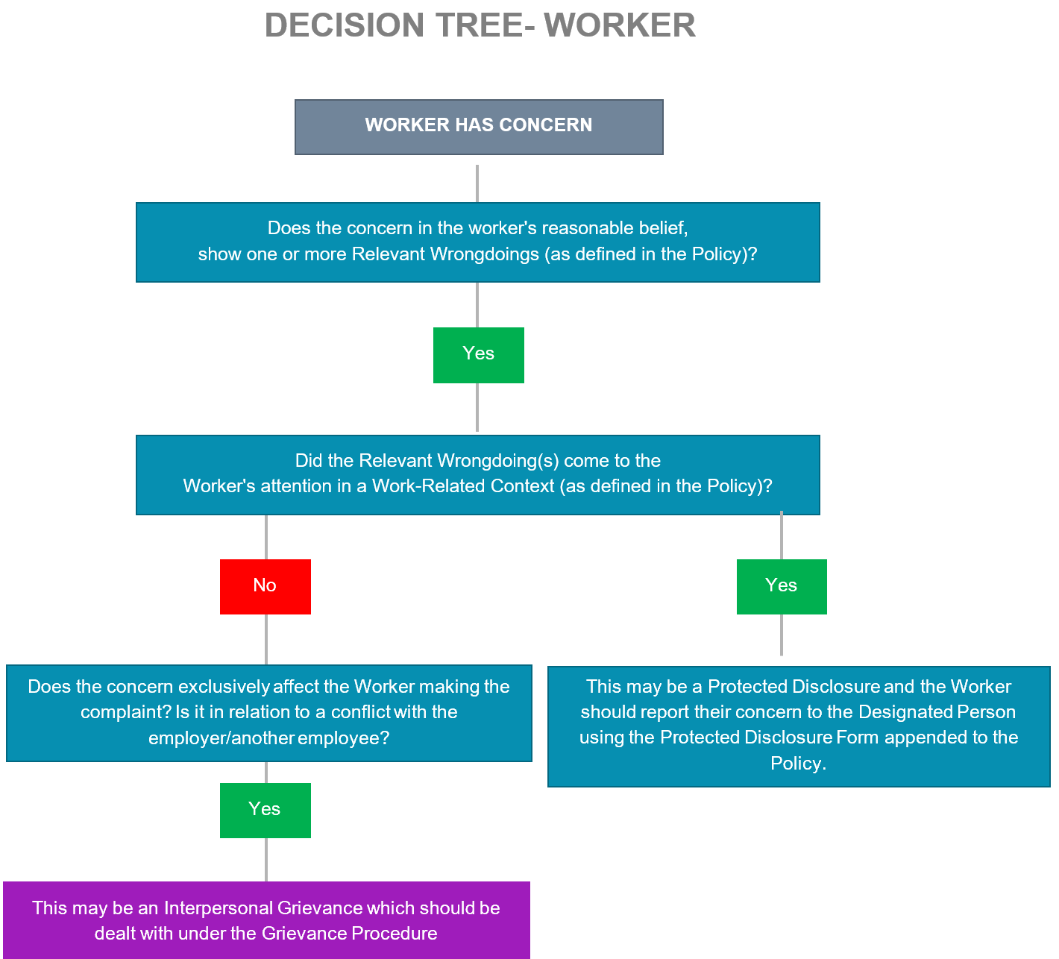

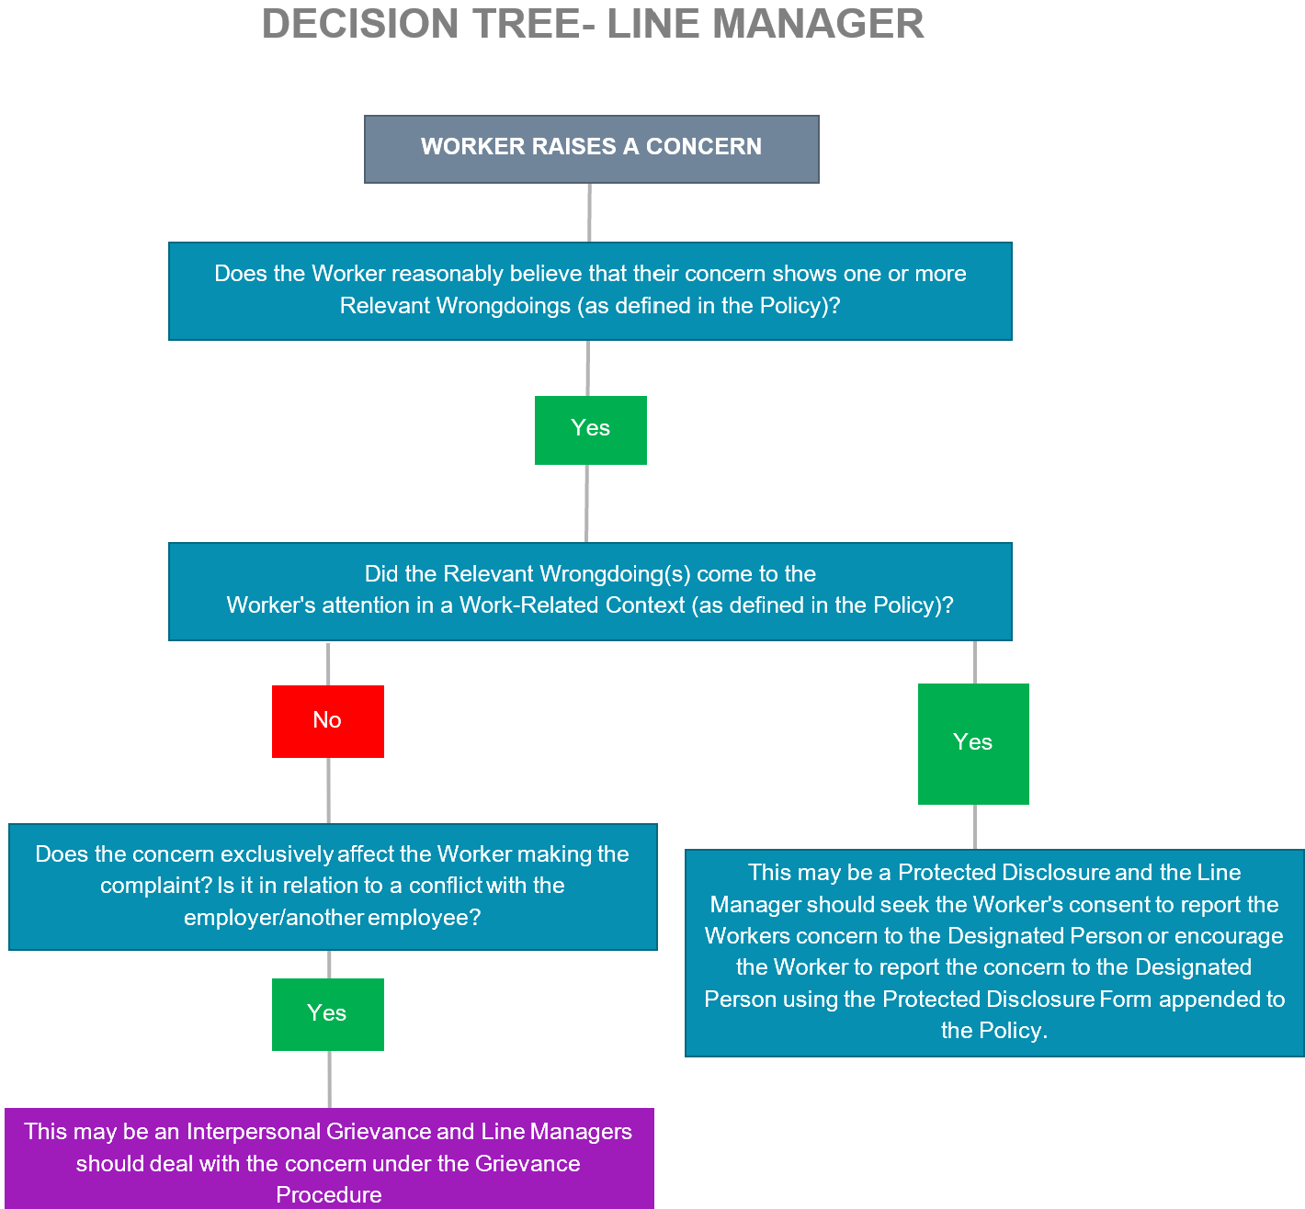

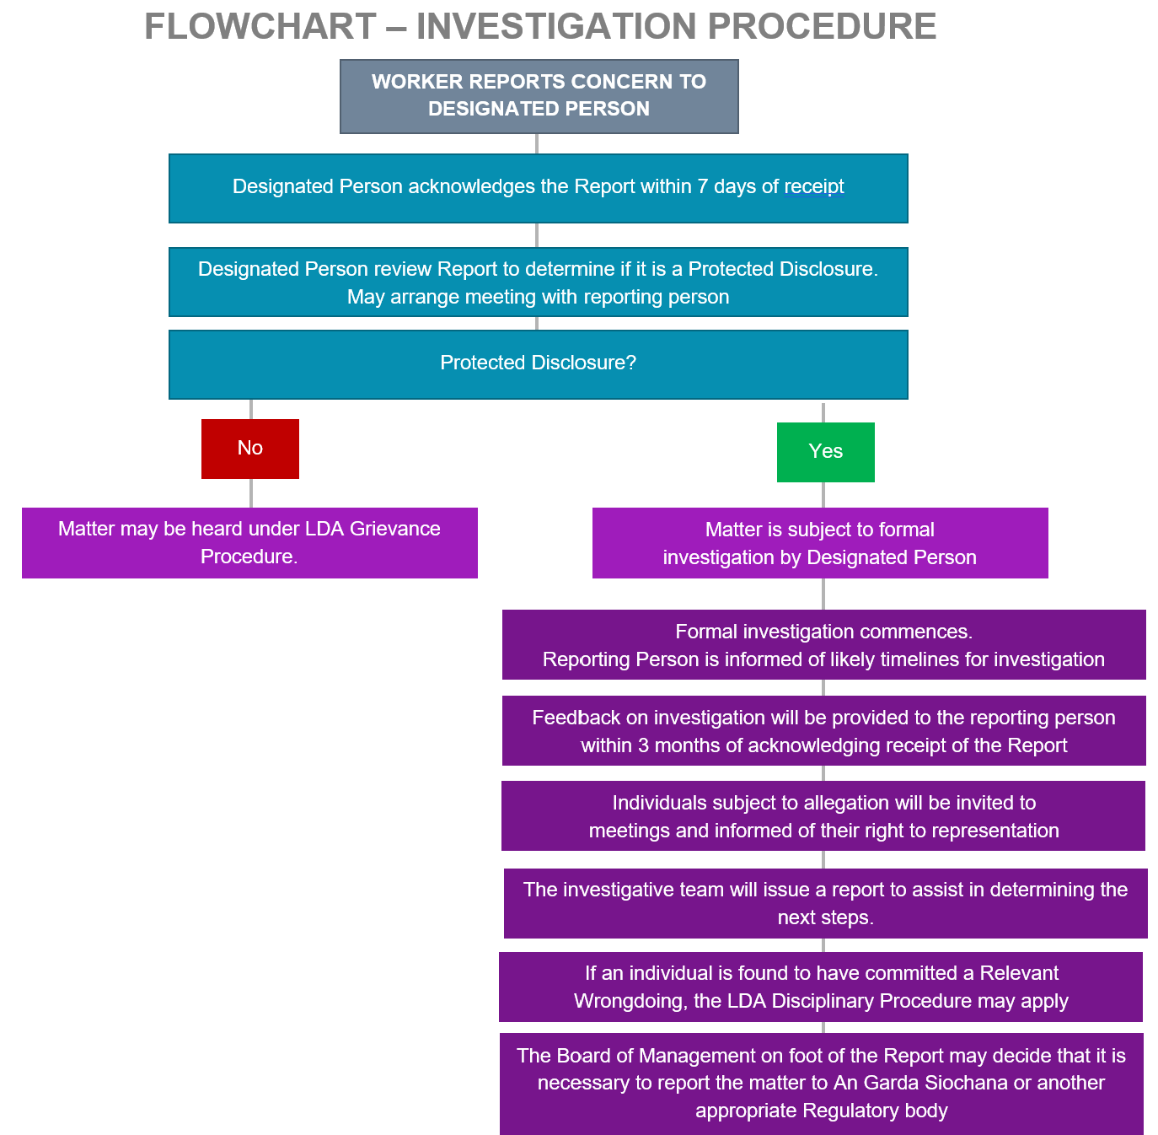

Barrett v Commissioner for An Garda Síochána & Minister for Justice & Equality [2022] IEHC 86

